Bingo Call Cards:

A note for teachers: This game is designed for review after use of the ‘Virtuali-Tee’ and app. Hold up a picture at random for students to cross off the corresponding digestive system term from their Bingo Card. The first student to correctly cross off 4 spaces in a row wins the game. A new coloured marker can be used for the next game.
Students may need guidance at first with the corresponding names of each picture before commencement of bingo.

Images in order of appearance:
Villi
Faeces (poo)
Liver
Duodenum
Large intestines
Oesophagus
Gall bladder
Pancreas
Stomach
Rectum
Chyme
Peristalsis
Acid
Bile
Saliva
Small intestines
Mouth
Bacteria
Enzymes (amylase)
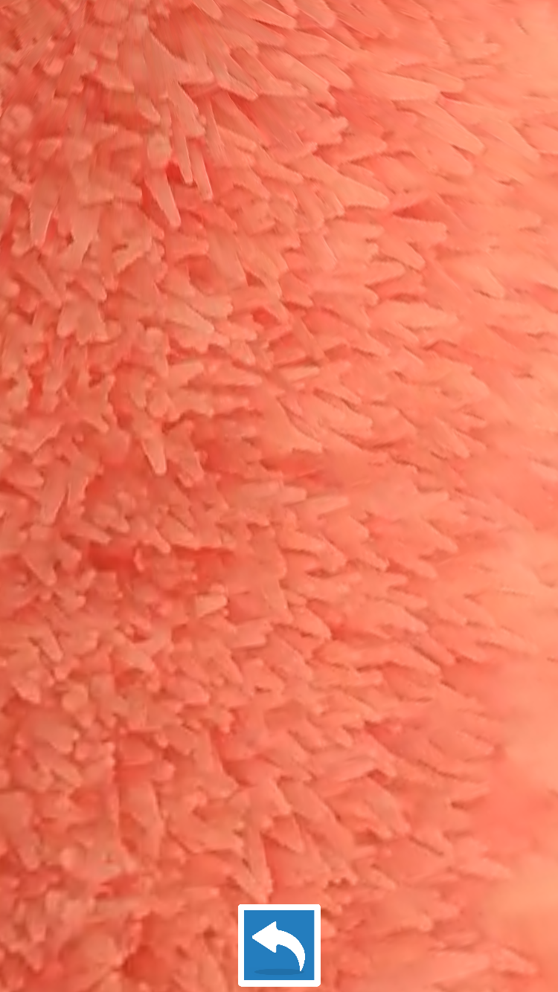
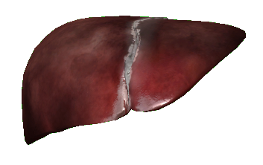


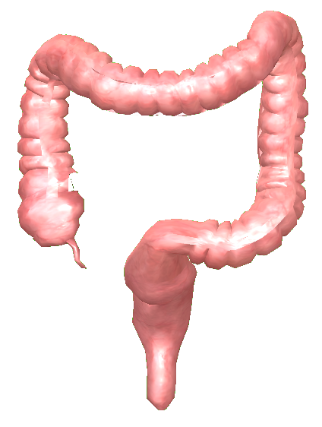
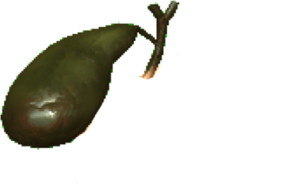


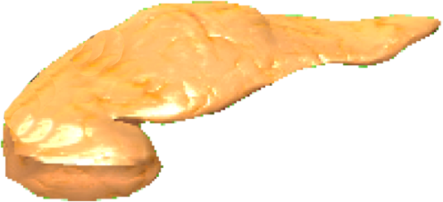
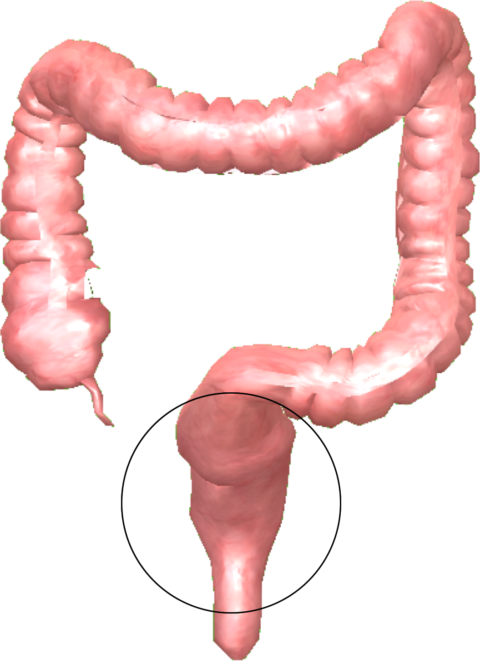
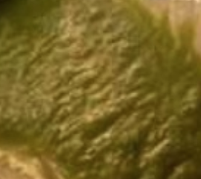
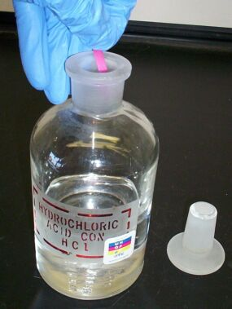
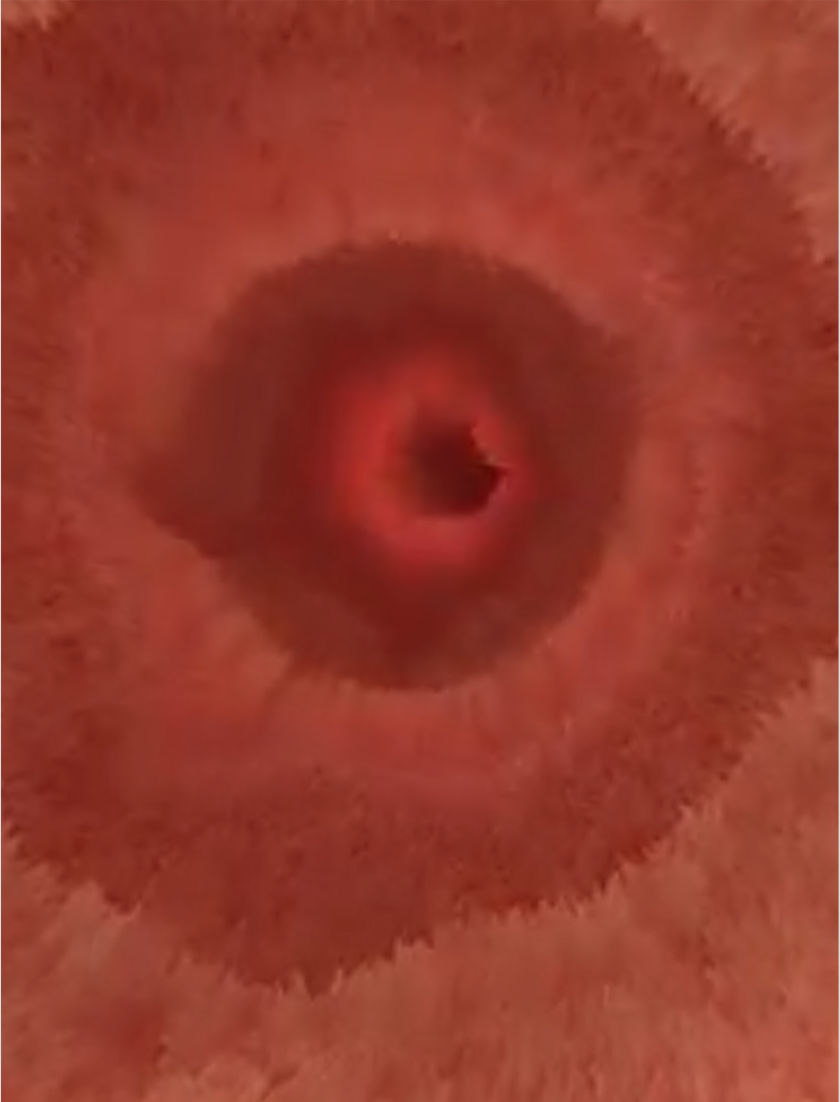
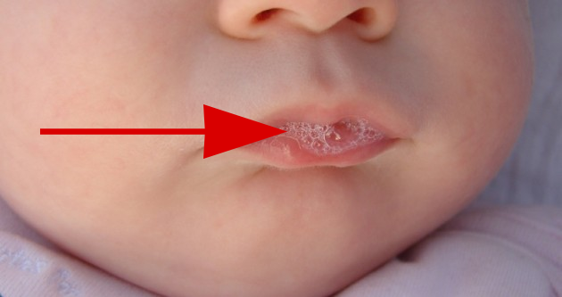
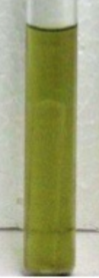
Image credit: Pereru https://commons.wikimedia.org/wiki/File:Saliva_Baby.jpg
