Blood Flow Around the Heart

Use arrows to show the complete flow of blood into and away from the heart.
Colour in the oxygenated blood RED and the deoxygenated blood BLUE.
Label the following: From the body, to the body, to the lungs, from the lungs.

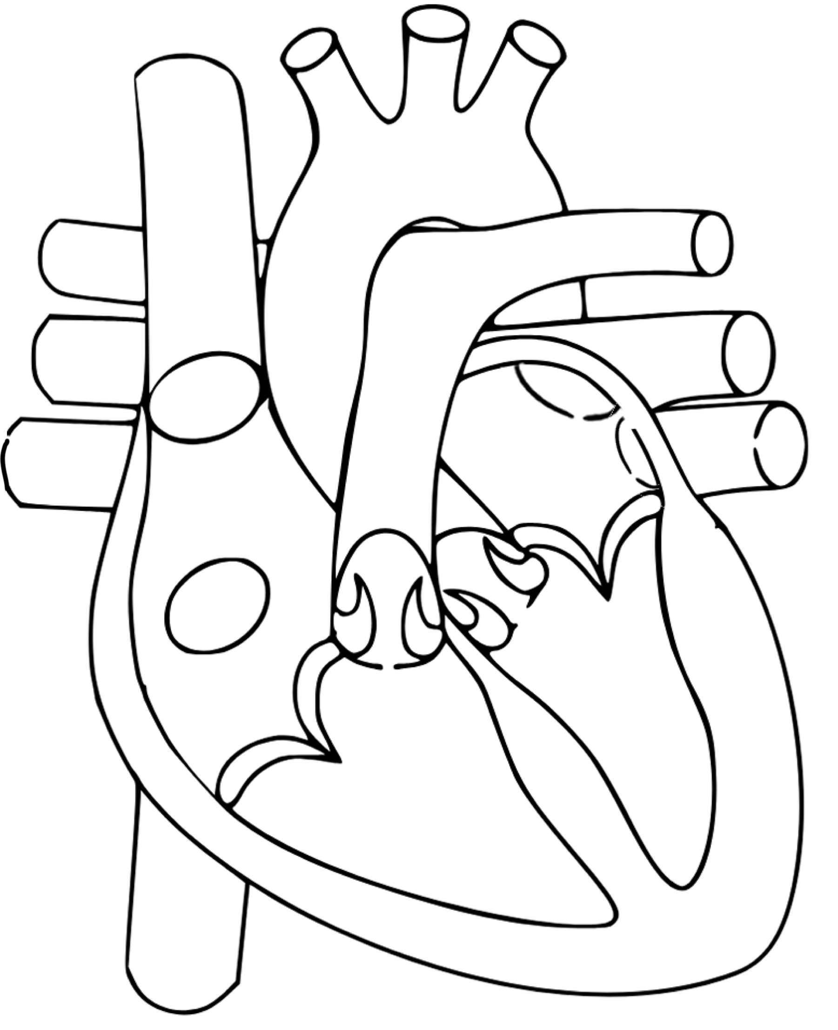
KEY:
Oxygenated blood
Deoxygenated blood

