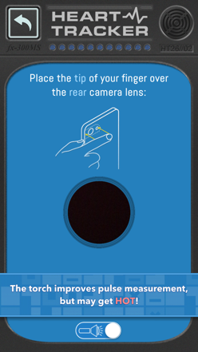
Learning about circulation… in a heartbeat!

Aim To investigate the effect of exercise on heart rate

Method
Use the Curiscope ‘Virtuali-Tee’ app to take heart rate measurements and then
note them down on the table. Measure your heart rate every minute until it has
returned to near the resting rate, this should be less than 10 minutes.

Materials
Timer or stop watch
Curiscope ‘Virtuali-Tee’ app heart rate monitor

Results
Time (minutes) | Activity | Heart rate (BPM)
0 | Resting
1 | Complete  1 minute of exercise (e.g. star jumps)
2 | Recovering
3 | Recovering
4 | Recovering
5 | Recovering
6 | Recovering
7 | Recovering
8 | Recovering
9 | Recovering
10 | Recovering
11 | Recovering
12 | Recovering

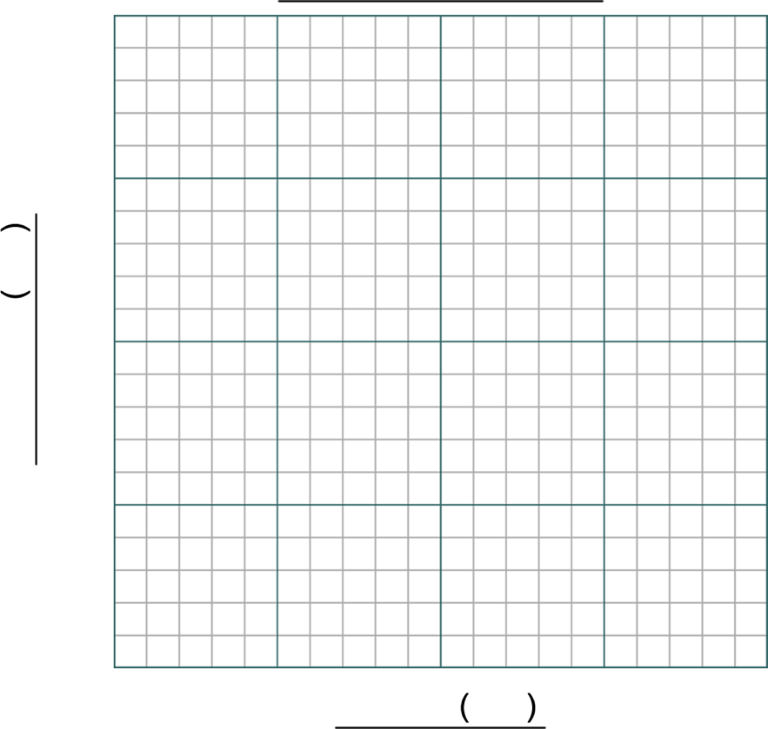
Discussion
- Describe the trend (pattern) of your graph.

- Was your final heart rate measured higher or lower than your resting heart rate? Explain why this might be so.

- What observations did you make about breathing rate throughout the experiment? Explain what you think might be the reason for this observation.

Conclusion

Extension
Can you devise an investigation to show the effects of different activities on heart rate? Does not need to be sports!

Group organisation – 4 students per group
Student 2: The Timer
Times the activity and informs other group members when to take measurements.
Student 1: The Human Subject
Does the exercise activity and has heart rate read as instructed.

Student 3: Heart Rate Measurer
Takes the heart rate of the Subject when instructed.

Warning: the heart rate monitor can get hot and the Subject must be free to move away from the light.
Student 4: The Recorder
Writes down measurements as taken by the Heart Rate Measurer.

Group organisation – 3 students per group

Student 1: The Human Subject
Does the exercise activity and measures heart rate when instructed.

Warning: the heart rate monitor can get hot and the Subject must be free to move away from the light.
Student 2: The Timer
Times the activity and informs other group members when to take measurements.

Student 3: The Recorder
Reads the heart rate and writes down measurements as taken by the Heart Rate Measurer.

