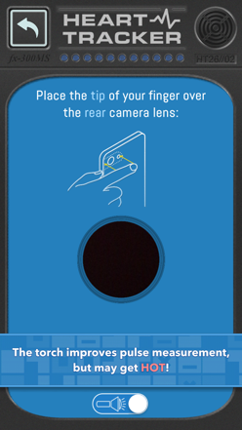
Learning about circulation… in a heartbeat!

Aim
Let’s investigate what happens to our heart rate when we rest and exercise.
Method
Use the Curiscope ‘Virtuali-Tee’ app to take heart rate measurements
and then note them down on the table.
Measure your heart rate every minute until it has returned to near
the resting rate, this should be less than 10 minutes.
Materials
Timer or stop watch
Curiscope ‘Virtuali-Tee’ app heart rate monitor
Results
Time (minutes) | Activity | Heart rate (BPM)
0 | Resting
1 | Complete  1 minute of exercise (e.g. star jumps)
2 | Recovering
3 | Recovering
4 | Recovering
5 | Recovering
6 | Recovering
7 | Recovering
8 | Recovering
9 | Recovering
10 | Recovering
11 | Recovering
12 | Recovering

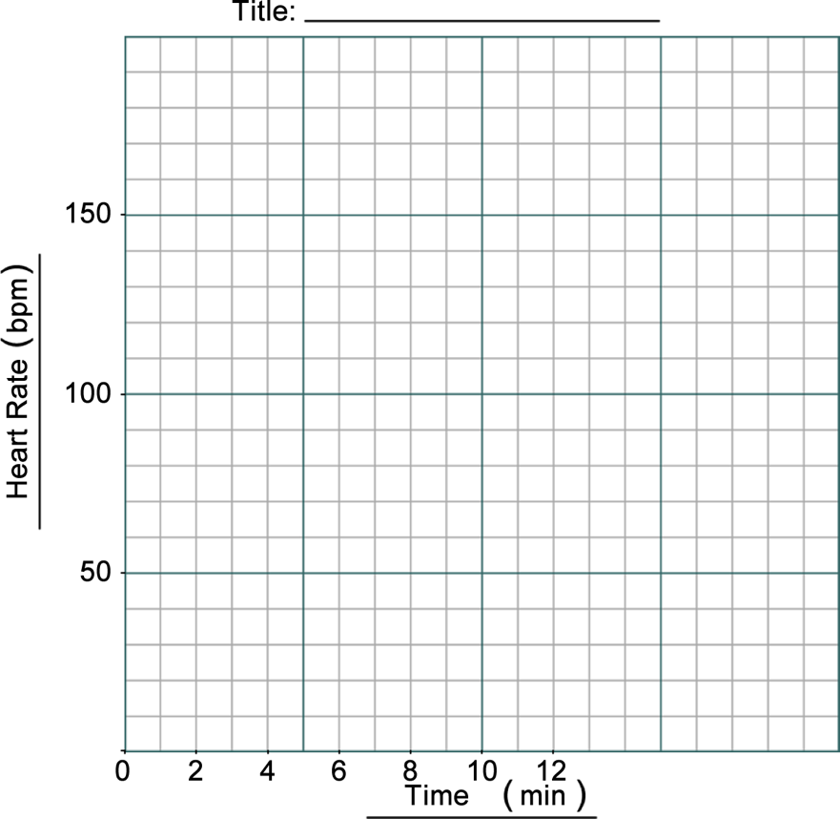
Discussion

- What happened to your heart rate when you exercised?

- Did your heart rate stay the same after exercising? Describe what happened.

- Did you notice anything different about your breathing rate while you were doing the experiment? Describe what happened.

Conclusion
What did you discover about your heart rate when you rest, exercise and recover?

Extension
Can you devise an investigation to show the effects of different activities on heart rate? Does not need to be sports!

Group organisation – 4 students per group
Student 2: The Timer
Times the activity and informs other group members when to take measurements.
Student 1: The Human Subject
Does the exercise activity and has heart rate read as instructed.

Student 3: Heart Rate Measurer
Takes the heart rate of the Subject when instructed.

Warning: the heart rate monitor can get hot and the Subject must be free to move away from the light.
Student 4: The Recorder
Writes down measurements as taken by the Heart Rate Measurer.

Group organisation – 3 students per group

Student 1: The Human Subject
Does the exercise activity and measures heart rate when instructed.

Warning: the heart rate monitor can get hot and the Subject must be free to move away from the light.
Student 2: The Timer
Times the activity and informs other group members when to take measurements.

Student 3: The Recorder
Reads the heart rate and writes down measurements as taken by the Heart Rate Measurer.

