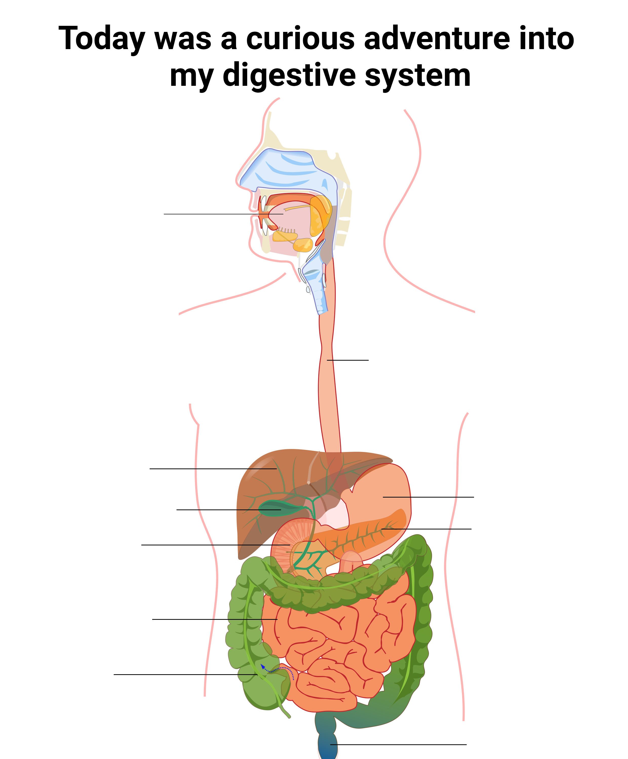
Alimentary Canal  (Gastro-Intestinal tract) | Accessory Organs
Stomach | Pancreas
Mouth | Liver
Oesophagus | Gall bladder
Large intestine
Rectum
Small intestine
Duodenum
Other labels
Salivary glands | Appendix
Anus

