The Digestive System Food Transit Times

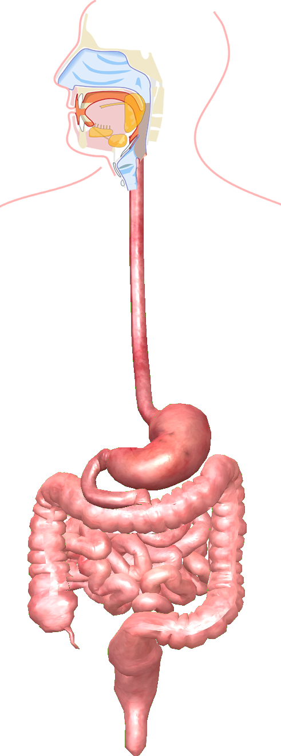
Label the organs of the Gastro-Intestinal (GI) Tract below. Complete the GI Tract flow chart showing the movement of food into the body and undigested food out of the body.

_____________________ 1 minute

_____________________ 4 - 8 seconds

_____________________ 2 - 4 hours

_____________________ 3 - 5 hours

_____________________ 10 hours - several days

